Description

SeaChange NGOD Gateway server consists of the NGOD Gateway server hardware and multiple software components.
The server or server pair run as a gateway server connects SeaChange MediaCluster streaming server architecture to Comcast NGOD compatible backoffice. It translates the NGOD messaging on asset and content management, session management and stream controls.

This SPD will focus on the software components of NGOD gateway server, please refer to the SPD of ALCOLU server for details of hardware specification

Features

The SeaChange NGOD Gateway server consists of the following features:
- The RTSP server-side – a socket server with RTSP protocol support:
RTSP, RFC 2326,
Following verbs are supported:
OPTION, DESCRIBE, SETUP, PLAY, PAUSE, TEARDOWN, PING, SET_PARAMETER, GET_PARAMETER, ANNOUNCE
NGOD RTSP extentions:
NGOD RTSP Usage Specification, Version 2.0;
NGOD Streaming Server Resource Ingterface (R2), Version 2.0;
NGOD Client Session Interface – S1/C1 (RTSP), Version 2.0;
Support of SSL on RTSP connection
- Support of NGOD Asset Management over HTTP protocol:
HTTP/1.1, RFC 2616
HTTP/1.0, RFC 1945
NGOD HTTP extensions
NGOD Asset Management – Asset A3, version 2.0:
TransferContent, GetTransferStatus, TransferStatus, CancelTransfer, ExposeContent, GetContentCheckSum, ContentCheckSum, GetContentInfo, DeleteContent, GetVolumeInfo
- Volume management and content access infrastructure over SeaChange MediaCluster architecture
- Distributed trick generation engines
- Resource management of SeaChange MediaCluster streaming devices:
Load balancing of multiple SeaChange MediaCluster spigots
Support of NGOD physical SOP, SOP group and logical SOP
- Session management:
Session lifecycle management and state machine automation
Support of safestore and failover
- Support of Motorola ECM pre-encryption MPEG files

Compatibility

- Comcast NGOD specifications version 2.0 on A3, R2, C1 and their dependencies are supported in NGOD gateway server version 1.0 (please verify the file version)
- SeaChange Vstream 5.4RC2 is supported in NGOD Gateway server 1.0
- SeaChange MDS and FMS MediaClusters are supported in NGOD gateway server 1.0
- Compatible with SSL 1.0 and 2.0

Limitations

The NGOD gateway server doesn’t offer internal propagation, it is up to NGOD APM to propagate contents among multiple volumes.

The NGOD gateway server can do load balancing within a SOP group or a logical SOP consists of multiple physical SOPs, but it is up to the NGOD ODRM to provide load balancing among multiple logical SOPs

Performance Characteristics

It is known support of service failover with Legato will introduce some performance trade-off. So the performance data are usually be gathered in two scenarios: with and without failover support. The following data are based on running the gateway server on SeaChange ACLUCO server with SeaChange FMS media cluster
- 23 setup per second and overall 200 operations per second steady test without failover supported, the average operation latencies are: overall 34.92msec, SETUP 27.02msec, PLAY 39.61msec, TEARDOWN 38.32msec
- 60 setup per second bluster test without failover supported, the average SETUP latency is 12 msec and the max latency is 203.8 msec of 3000 sessions

Not Available in This Release

- Support of NGOD D4 and D5 is not available in this release, will be covered in the following version
- IPv6 is not covered in this release of NGOD gateway server
- Realtime ingestion is not available in NGOD 2.0 specification and this release of NGOD gateway server

Configuration

The combination of NGOD gateway server and one or multiple SeaChange MediaCluster works as a NGOD streaming server in a typical Comcast NGOD compatible site. The following diagram shows how the NGOD gateway server is deployed.
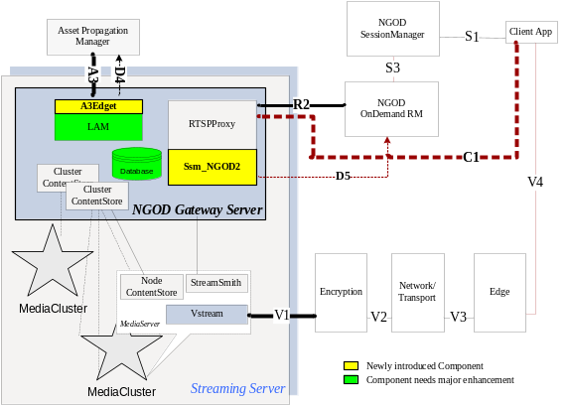

In which, RTSPProxy, LAM (known as Multiverse service) and ClusterContentStore services run on the NGOD gateway server while StreamSmith, NodeContentStore and RtfCPNode service run on each node of the SeaChange MediaCluster.

The NGOD Gateway Pair

To provide service failover, the NGOD gateway server often be delivered as a server pair with Legato co-Standby supported. The following diagram shows how the gateway components are deployed in such a server pair:
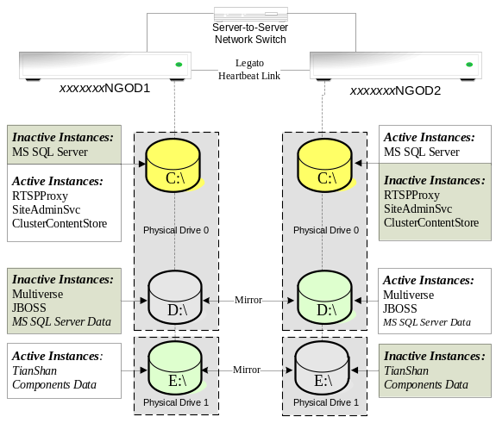

Major Components on the Gateway Server(s)

RTSPProxy
RtspProxy runs as a RTSP socket server on a PC-compatible server as a reliable NT service to accept RTSP requests. It offers users a flexible extension opportunity with modules, a plugin-architecture.

Ssm_NGOD2
Ssm_NGOD2 is a plugin implementation of RTSPProxy, it supports the NGOD RTSP extensions and support NGOD R2 and C1 interfaces

LAM
Known as a part of SeaChange Multiverse service, it is a web application that runs as a gateway components between NGOD A3 speciation and ContentStore APIs

ClusterContentStore
ClusterContentStore run as a NT service, provides the volume and content access to SeaChange MediaCluster via a unified file system. It is also the central management of the distributed content provision engines

Components on SeaChange MediaCluster nodes

StreamSmith
StreamSmith runs on each MediaCluster node as a reliable NT service. It handles streaming API invocations and drives the stream execution over SeaChange Vstream.

NodeContentStore
NodeContentStore is a slave module of the ClusterContentStore. It takes the remote invocation forwarded by the ClusterContentStore and handle the request via local Vstream APIs

RtfCPNode
RtfCPNode is a distributed content provion engine, it fetches the media content from the source, performs the necessary SeaChange trick generation and import the prepared media content into the SeaChange MediaCluster volume

Software and Hardware Requirements

NGOD Gateway Server | Version
Operation System | Windows 2003
Legato | 5.1
MediaCluster Node | Version
Operating System | Windows 2003
Vstream Kit | Version 5.4.2RC2
OpenSSL | Version 0.9.8a
NGOD Backoffice of the deployment | Compatible with NGOD specification 2.0

